**Sonicwall Configuration for TeleVoIPs – SonicOS 7**

Follow the directions below to ensure proper configuration and QoS settings for SonicWall firewalls with SonicOS 7 and higher. Please understand, instructions may vary based on the model and firmware version of your device.

1. **Required Changes**
2. Navigate to Network across the top. Then on the left side under **Firewall** > **Flood Protection** section set **Default UDP Connection Timeout** to **300** on the **UDP Tab.** Then click **Accept** to save the changes

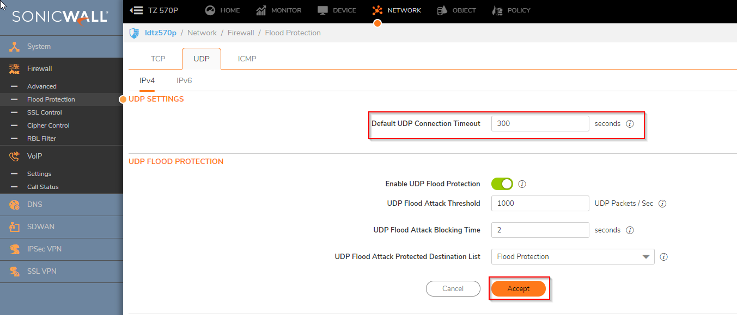

1. Navigate to Policy across the top. The on the left side under **Rules and Policies** > **Access Rules**, Edit the Rule that applies to the outbound traffic that the TeleVoIPs phones are on. Normally this is the Default **LAN to WAN** rule. Update the **UDP timeout** to **300.** Then click **Save.**

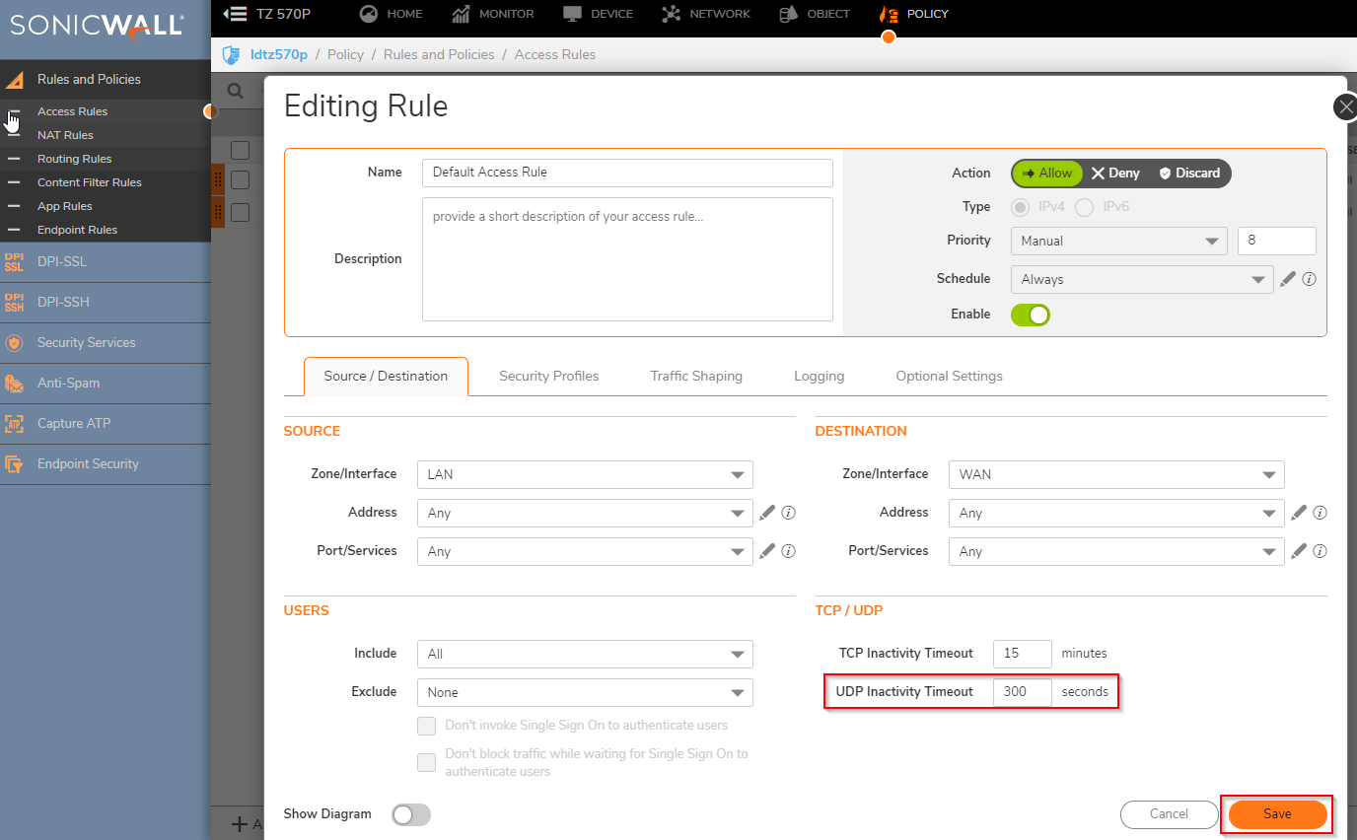

5. Navigate to Network across the top. The on the left side under **VOIP**, select **Settings**, enable the option for **Enable consistent NAT**. Click **Accept** to save.

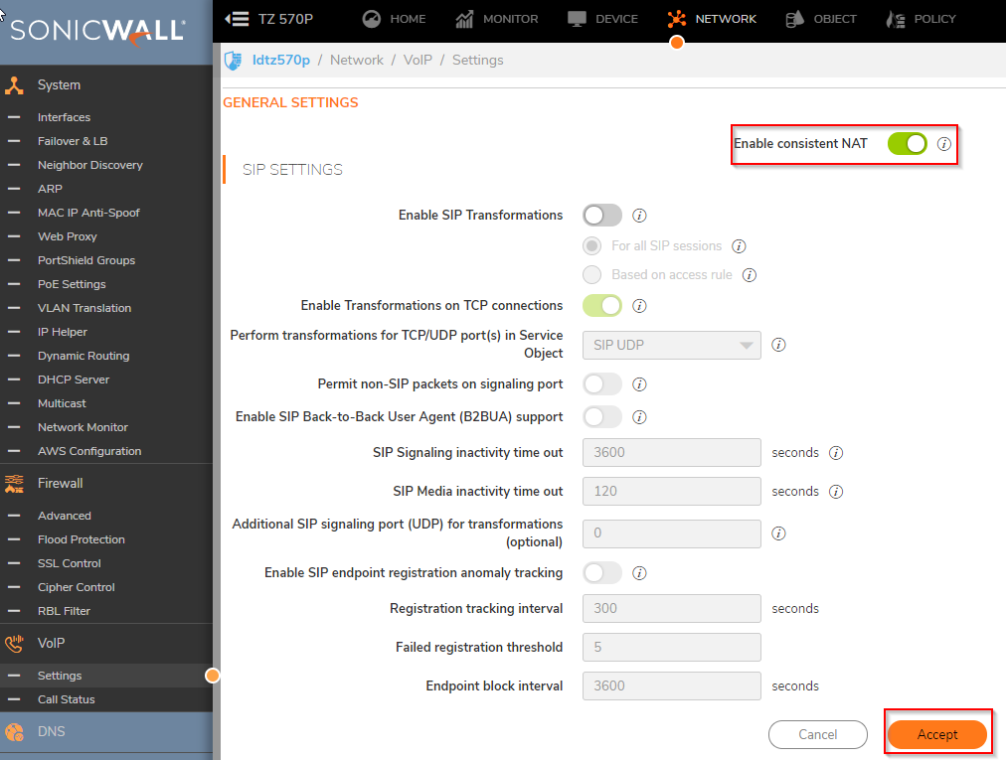

1. If you are still experiencing issues, please reach out to [support@televoips.com](mailto:support@televoips.com), as additional settings to Flood or Intrusion Protection may be required.
2. **QoS Optimization (Recommended)**
3. **Enabling Bandwidth Management (Step 1)**
4. Go to **Firewall Settings > BWM**.
5. Enable **0 Realtime** and set to 10% - 20%, Then modify either High or Low so total adds up to 100%
6. Click **Accept** to save the settings.

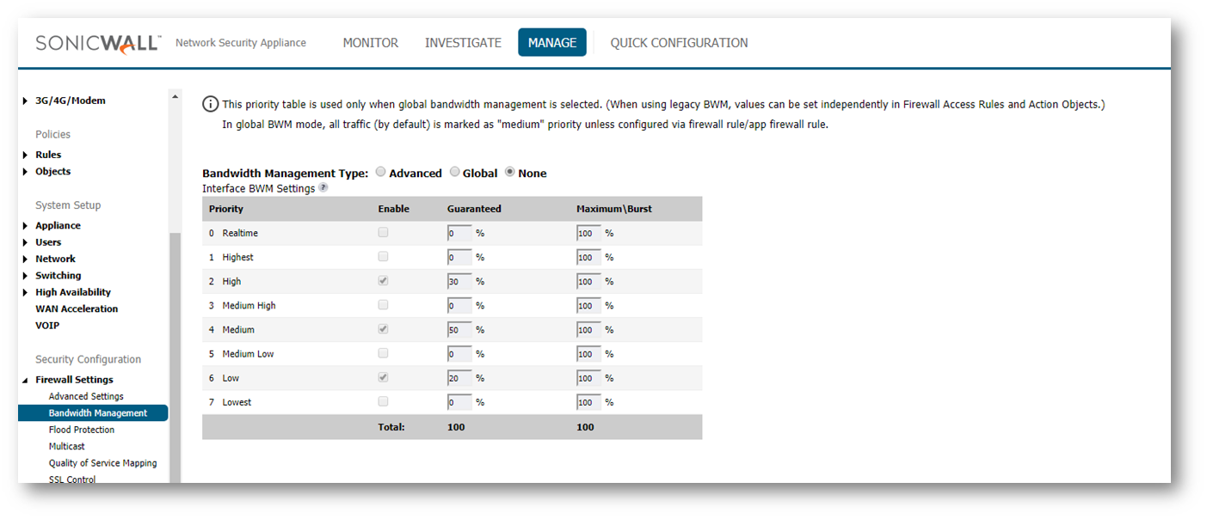

1. **Enabling Bandwidth Management (Step 2)**
2. Go to **Network** > **Interfaces** and on the right side of the screen open the **Configure** menu for the desired **WAN Interface**.

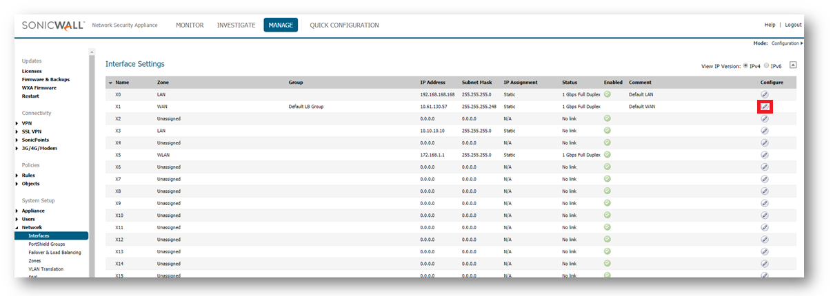

1. Go to the **Advanced** tab and **Enable** both the **Ingress** and **Egress** **Bandwidth Limitation**checkboxes.

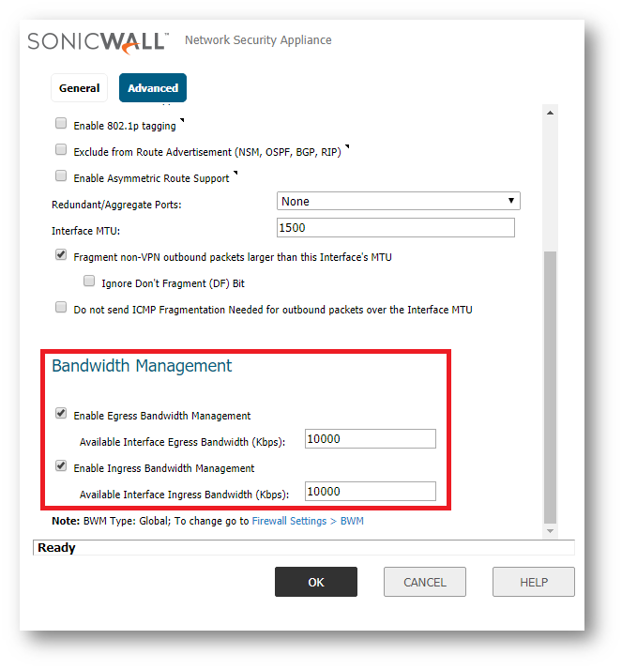

1. Input the **Ingress** and **Egress** Speeds of your WAN in Kbps. If you're unsure of these values, contact your ISP.

4. Click **OK** to save the settings and close the window.

1. **Enabling Bandwidth Management (Step 3)**
   1. Navigate to **Rules** > **Access Rules** and find the **Access Rule** you would like to apply **BWM** to:

If a new Access Rule is required, click **Configure** on the relevant **Access Rule** or click **Add** and create the rule by entering the desired **Source, Destination, Service**, etc. into the fields.

If creating a new rule set, click **Allow** from **Any** **to TeleVoIPs Phone server IP and Fax** server if applicable and **Any Port** and **Any Service**.

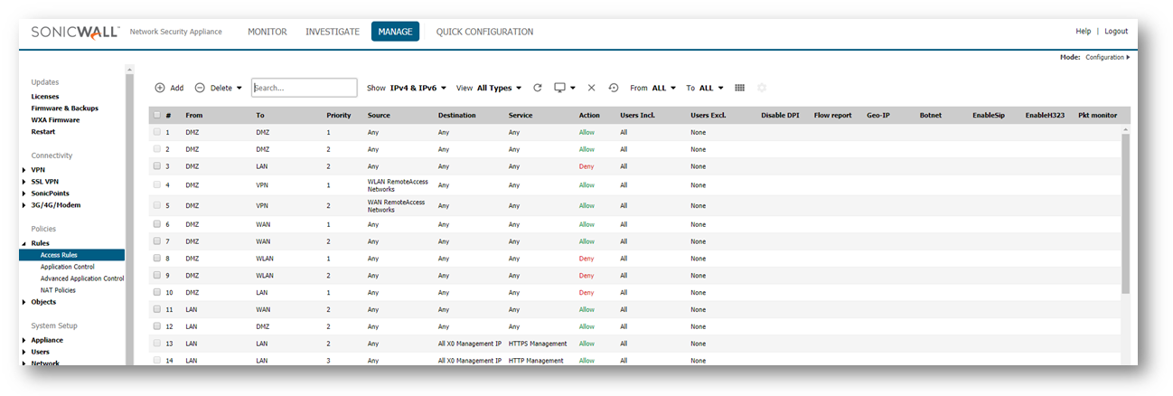

* 1. On the **Access Rule** creation/modification screen, select the **BWM** tab. Enable **Egress and Ingress Bandwidth Management** and select **0 Realtime Bandwidth Priority.**

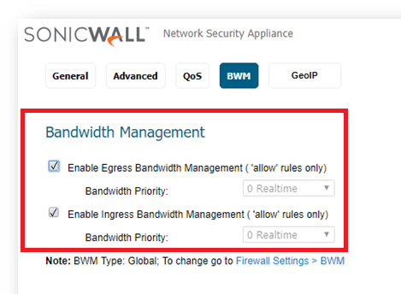

* 1. Click **OK** to save the settings and close the window